 | November 2026 www.professionalautomotivetraining.net Phone: 928-486-2350
Sun | Mon | Tue | Wed | Thu | Fri | Sat
1   | 2  2G  RENEWAL CLASSES  CAN BEGIN ANYTIME TO FIT YOUR SCHEDULE  CALL OR TEXT FOR DETAILS | 3  Professional Emission Inspector Training Since 2006 | 4  2G PREP  12 hour  classes are meant to enable a 1G tech to Pass the DMV 2G “Challenge Test” | 5  SHOP TECH GROUP  ESSENTIAL KNOWLEDGE COURSES ARE AVAIALBLE AT A VERY REASONALBLE COST | 6  HYBRID VEHICLE TRAINING IS AVAILABLE  BASIC SAFETY to ADVANCED ANALYSIS MAINTENANCE SERVICING | 7  Professional Training Classes are available in  Las Vegas  Call 928-486-2350
8 Essentials Class  GAS DIRECT FUEL INJECTION  Fuel Trims –  Bias Voltage  DSO Analysis | 9  START 1G  Emission  Inspector class  IN PERSON  6 PM TO 10 PM | 10  1G Class  6pm to 10pm  CLASSROOM  IN-PERSON CLASS | 11 Veterans Day  1G Class  6pm to 10pm  CLASSROOM  IN-PERSON CLASS | 12  1G Class  6pm to 10pm  CLASSROOM  IN-PERSON CLASS | 13  NO CLASS TODAY  1G CLASS  STUDY DAY | 14  Practical Practice  & 1G FINAL EXAM  Exact Time To Be Determined by Class  Daylight Hours
15 Essentials Class  Advanced Ignition Systems Class  Waste Spark to  Coil On Plug Testing and Analysis | 16 SHOP OWNER CAN’T FIND COMPETENT TECHS?  IT IS UP TO YOU TO “TRAIN YOUR OWN!” I AM HERE TO HELP YOU DO JUST THAT | 17 2G  DMV PREP  or  RENEWAL CLASSES  AVAILABLE | 18 2G  DMV PREP  or  RENEWAL CLASSES  AVAILABLE | 19 2G  DMV PREP  or  RENEWAL CLASSES  AVAILABLE | 20 2G  RENEWAL CLASSES  CAN BEGIN ANYTIME TO FIT YOUR SCHEDULE  CALL OR EMAIL FOR DETAILS | 21  All scheduled dates are subject to modification, as long as there is no adverse effect on a student
22  Essentials Class  ADVANCED HVAC R1234yf TRAINING  IN PERSON TRAINING  CAN BE SCHEDULED FOR GROUPS | 23 2G  DMV PREP  or  RENEWAL CLASSES  AVAILABLE | 24 2G  DMV PREP  or  RENEWAL CLASSES  AVAILABLE | 25 2G  DMV PREP  or  RENEWAL CLASSES  AVAILABLE | 26 Thanksgiving Day  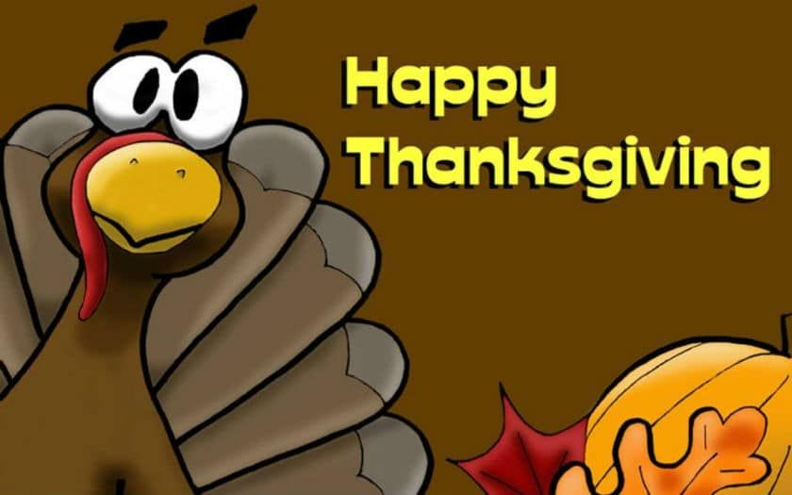 | 27  NO CLASS TODAY | 28  QUESTIONS?  Call or Email for further information and how to book these classes
29 2G  RENEWAL CLASSES  AVAILABLE  CALL OR TEXT FOR INFO | 30 2G  RENEWAL CLASSES  AVAILABLE  CALL OR TEXT FOR INFO | I have a decade of teaching experience at the college level. I hold a bachelors degree in Workforce Education from UNLV. I have presented 118 training classes over the last ten years for Delphi Technologies in 22 different states. Additionally, I have presented 57 training webinars for Delphi. This is quality training available here locally. My experience includes 35 years as a and shop owner and ASE certified master technician.

